Economics 1st 9 week’s Note Packet
Unit 1
Scarcity and Economic Reasoning
Key word | Information/Definition | Memory clue
Economics
Economy
Microeconomics
Macroeconomics
Economic model
Margin
Marginal benefit
Marginal cost
The Law of diminishing marginal utility
Marginal analysis
Goods
Services
Scarcity
Trade-off
Opportunity cost

Production Possibilities Curve/Frontier

Early Economic Views
Economist |  | Economic View | Claim to Fame
Adam Smith
Scotland
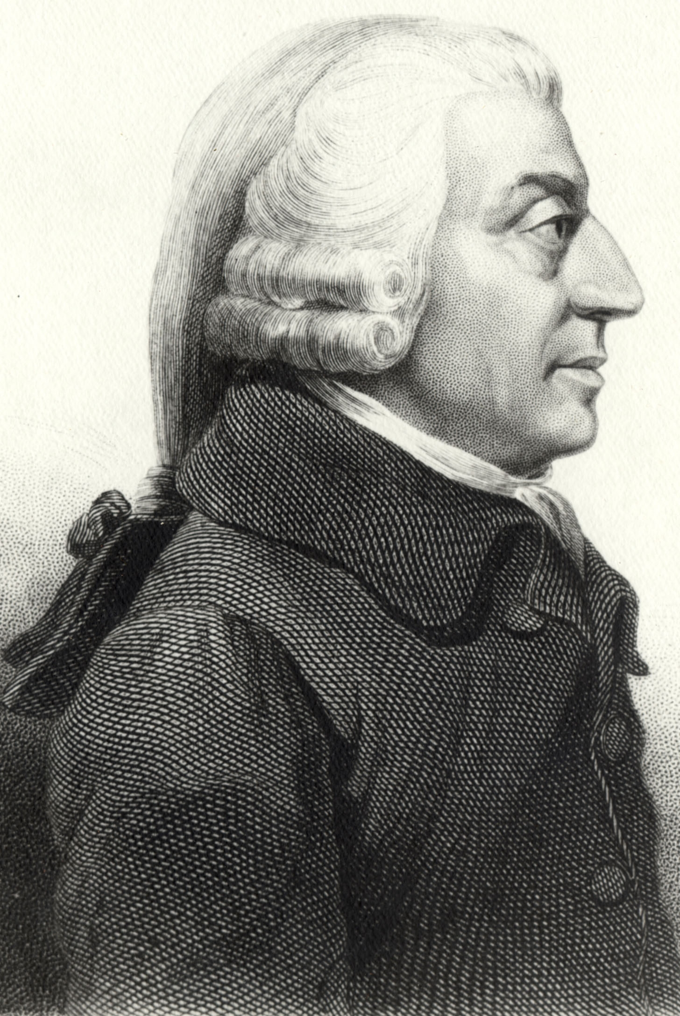
1723-1790
Thomas Malthus
England
1766-1834
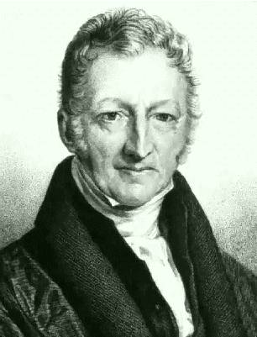
David Ricardo
England
1772-1823
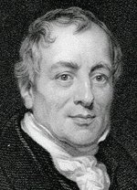
Karl Marx
Germany
1818-1883
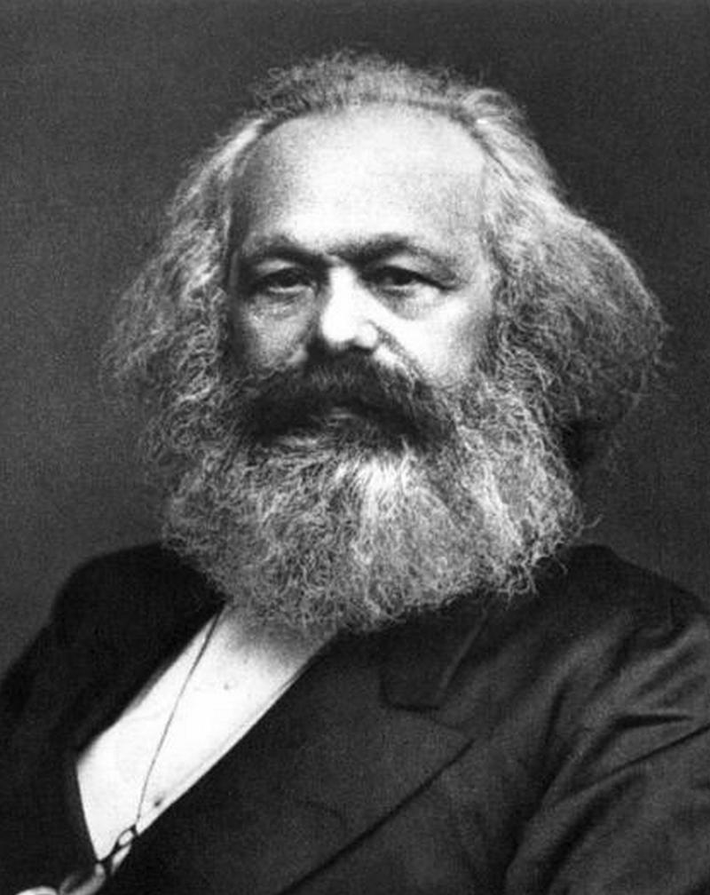

Factors of production
Land
Labor
Capital

Economic Systems

Economic System

What 3 questions must every economy answer?

Traditional Economy
What
How
Who
Example

Command Economy
What
How
Who
Example

Market Economy
What
How
Who
Example

Mixed Economy
What
How
Who
Example

Goals of American Economic Policy

Goals | Definitions

Private property

Why are private property rights important

Who do private property laws protect, and from whom?

Unit 2
Supply and Demand
Key word | Information/Definition | Memory clue
Consumer Sovereignty
Demand
Individual demand
Market demand
Quantity demanded
Law of demand
Demand Schedule
Demand curve

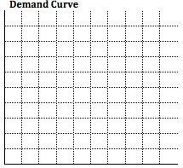

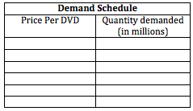

Demand shift
Real Income effect
Substitution effect
Complementary good

Determinants of Demand
Determinant | How it affects demand

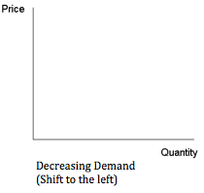
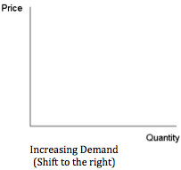
Elasticity
Elastic demand
Inelastic demand

Determinants of Elasticity
Determinant | How it affects elasticity of demand
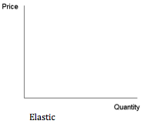
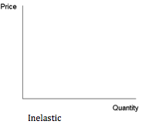

Supply
Quantity supplied
Law of supply
Supply curve
Law of diminishing returns

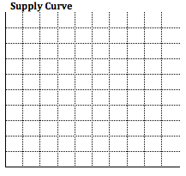
Supply Schedule
Price per DVD | Quantity Supplied in millions

Determinants of Supply
Determinant | How it affects supply

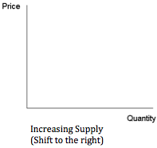
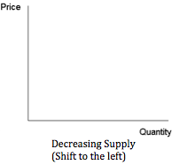
Equilibrium price
Price Ceiling
Shortage
Price floor
Surplus
Finding the equilibrium price, surplus, and shortage

Unit 3
Business organization and market structures

Entrepreneurship
7 Traits of Entrepreneurs
Tenacity
Passion
Tolerance of Ambiguity
Vision
Self-Belief
Flexibility
Rule-Breaking

How Entrepreneurs Benefit the Economy

Types of Entrepreneurs | What they do

Business Organization

Sole proprietorship

Advantages | Disadvantages

Partnership

Advantages |  | Disadvantages
Various Partnerships
Partnership Type | Details

Franchise

Advantages | Disadvantages

Examples of a franchise
Not examples of a franchise

Business Expansion and Financing

Revenues/Receipts
Profit

Ways to Expand
Retained earnings
Borrow
Sell stock

Increasing productivity

Marginal Analysis In Business Decisions

Marginal analysis for a poster shop when posters sell for $3 each and the going wage rate is $8 an hour.
# of Employees | Posters made per hour | Total revenue per hour | Supply cost per hour | Total labor cost per hour | Profit per hour
1 | 8 | $24 | $8 | $8 | $8
2 | 17 | $51 | $17 | $16 | $18
3 | 26 | $78 | $26 | $24 | $28
4 | 33 | $99 | $33 | $32 | $34
5 | 38 | $113 | $38 | $40 | $35
6 | 41 | $123 | $41 | $48 | $34

Corporation

Advantages | Disadvantages

Corporate Charter
Stock
Common Stock | Preferred Stock
Share Holder
Board of Directors

Merger
Merger Type | How is it structured

Labor
Labor Unions
Collective Bargaining
Mediation
Arbitration
Strike
Picketing
Boycott
Lockout
Injunction

Market Structures

Market Structure

Perfect Competition
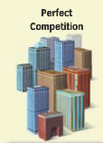
Characteristics of Perfect Competition

Monopoly
Characteristics of Monopolies

Types of Monopolies
Type | Definition | Examples
Oligopoly
 |  | 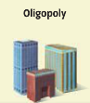
Characteristics of Oligopolies
Monopolistic Competition
 |  | 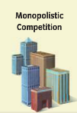
Characteristics of Monopolistic Competition

Market Structure Table
 | Perfect Competition | Monopoly | Oligopoly | Monopolistic Competition
Number of firms
Variety of goods
Control over prices
Barriers to entry
examples

