Economics 2nd 9 week’s Note Packet
Unit 4
Money

What is Money

Functions of Money
Function | What it means

Types of Money
Type | Definition

Characteristics of Money
Characteristic | Meaning

Financial Institution | Services provided
Commercial Bank
Credit Union
Investment Bank
Central Bank

Interest

Calculating Interest

Capital gains
Capital loss
Maturity

Saving and investing tools

Savings account
Money market deposit account (MMDA)
Time deposits
Certificate of deposit (CD)
Bonds
Tax-exempt bonds
Stocks
Mutual funds
401K
403B
Individual retirement account (IRA)
Roth IRA

The Money Supply

Money supply
M1
Near monies / moneys
M2

Types of Money in the Money Supply | M1 | M2
Currency (bills and coins)
Checkable deposits
Traveler’s checks
Savings deposits
Timed deposits
Other near monies

The United States Federal Reserve System
(The Fed)

Functions
Services

Structure of The Fed

Unit 5 Notes
National Economic Performance

Gross Domestic Product
Gross Domestic Product (GDP)

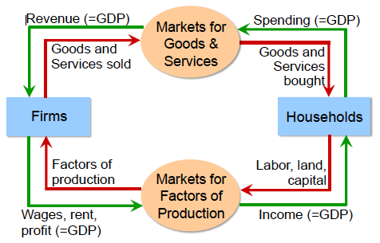

Formula for GDP: Y(GDP)=C+I+G+X
C
I
G
X

In order to be counted in a nations GDP, goods and services must:
1
2
3

Nominal GDP
Real GDP

Inflation
Inflation
Disinflation
Deflation
Stagflation
Hyperinflation

Causes of inflation
Cost-push inflation
Demand- pull inflation

Consumer Price Index (CPI)
Measuring the CPI
Major groups in the CPI

Year | Annual Average | Annual Percent Change  (rate of inflation)
1913 | 9.9
1914 | 10.0 | 1.3%
1915 | 10.1 | 0.9%
1930 | 16.7 | -2.7%
1931 | 15.2 | -8.9%
1932 | 13.6 | -10.3%
1955 | 26.8 | -0.3%
1956 | 27.2 | 1.5%
1957 | 28.1 | 3.3%
1996 | 156.9 | 2.9%
1997 | 160.5 | 2.3%
1998 | 163.0 | 1.6%
1999 | 166.6 | 2.2%
2010 | 218.1 | 1.6%
2011 | 224.9 | 3.2%
2012 | 229.6 | 2.1%
2013 | 233.0 | 1.5%
2014 | 236.7 | 1.6%
2015 | 234.7 (Feb) | -2.0%

Consumer Price Index, 1913- CPI-U Base year is chained; 1982-1984 = 100

Picturing the Economy

Aggregate Demand
Aggregate Supply

Aggregate Demand and Supply Curve

The Business Cycle
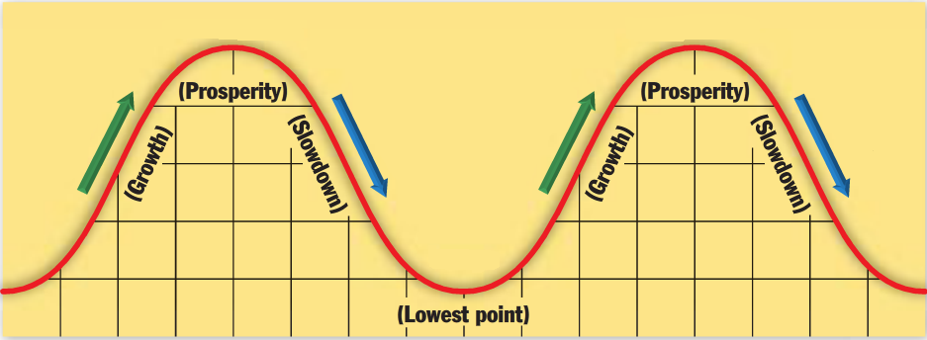
 | Term | Definition
1 | Peak/Boom | Period of prosperity in a business cycle in which economic activity is at its highest point.
2 | Contraction | Part of the Business cycle during which economic activity is slowing down. (Less than 6 months)
3 | Recession | Part of the business cycle in which the nations output (real GDP) declines for at least six months.  (6 consecutive months or longer)
4 | Depression | Major slow down of economic activity.
5 | Trough | Lowest part of the business cycle, in which the downward spiral of the economy levels off.
6 | Expansion/Recovery | Part of the business cycle in which economic activity slowly increases.

Unemployment
How is the unemployment rate calculated?
What is the labor force?

Who is in the labor force?
Who is not in the labor force?

 | Type of Unemployment | Definition | Example
1 | Cyclical
2 | Structural
3 | Seasonal
4 | Frictional

Unit 6 Notes
The Role of Government

Fiscal Policy

Expansionary Policy
Contractionary Policy

Public Goods

Social Programs

Social Security
Medicare
Medicaid

Externalities
Positive | Negative

National Deficit

National Debt

Government Regulatory Agencies

Acronym | Official Name | What does it do?
FDIC
OSHA
EPA
SEC
FTC
FDA
FCC
EEOC
NRC
NTSB

Sherman Anti-Trust Act

Taxation

Tax base

Forms of Taxation
Tax Type | How is the tax applied | Example

Other Taxes
Tax | How it is collected

Sources of Revenue
Local
State
Federal

Monetary Policy and the Federal Reserve

Dual Mandate

Tools of the Fed
Interest Rates
Reserve Requirements

Open market operations
Problem | Action | Result

Unit 7 Notes
Trade

Why Do Countries Trade?

Advantages
Absolute advantage
Comparative Advantage
Specialization

Trade Balance
Positive trade balance
Negative trade balance

Trade Restrictions
Embargo / Sanctions
Revenue tariff
Protectionist tariff
Import quota

Trade Organizations
NAFTA

Currency
Exchange rate
Fixed exchange rate
Devaluation
Flexible exchange rate
Depreciation
Exchange Market

