Unit 2 Notes
Supply and Demand

Key word | Information/Definition | Memory clue
Demand
Individual demand
Market demand
Quantity demanded
Law of demand
Demand Schedule
Demand curve

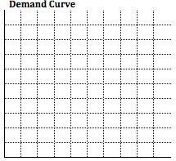

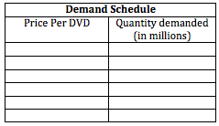

Demand shift
Income effect
Substitution effect
Complementary good

Determinants of Demand
Determinant | How it affects demand

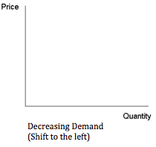
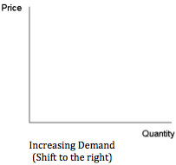
Elasticity
Elastic demand
Inelastic demand

Determinants of Elasticity
Determinant | How it affects elasticity of demand
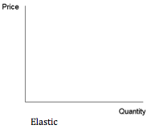
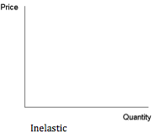

Supply
Law of supply
Quantity supplied
Supply curve
Law of diminishing returns
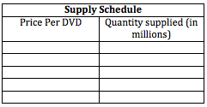
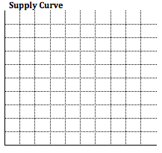
Determinants of Supply
Determinant | How it affects supply

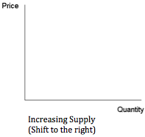
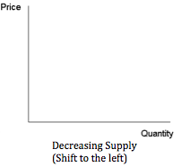
Equilibrium price
Price Ceiling
Shortage
Price floor
Surpluses
Finding the equilibrium price, surplus, and shortage

